**Workflow**

* Day build workflow  
  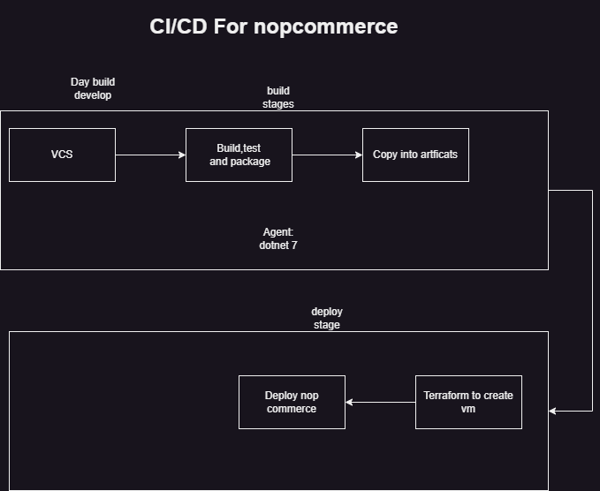
* Nightly Build workflow  
  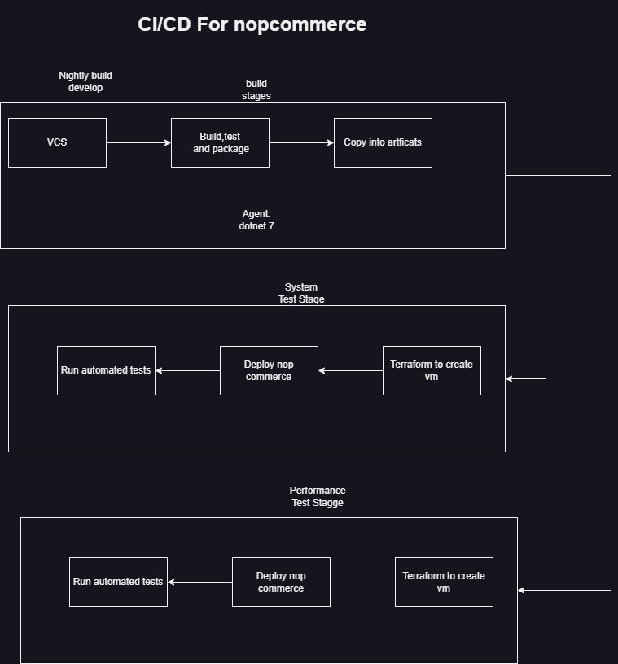

**Day build workflow**

* Branch name: workshop-develop
* reference use nopCommerce <https://github.com/CICDProjects/nopCommerceJuly23>
* Manual steps:

# dotnet-sdk 7.0

dotnet build src/NopCommerce.sln

* activity 1
  + figure out where the packages are getting built src/Presentation/Nop.Web/bin/Debug/net7.0
  + we need copy these packages into artifacts
* activity 2:
  + configure agent pool
    - dotnet 7
  + Write a pipeline with a build stage to build the code using dotnet build src/NopCommerce.sln
  + publish the artifacts to nopreleaseartifacts
* Pipeline so far

---

trigger:

- workshop-develop

stages:

- stage: buildstage

displayName: Build flea commerce

pool:

vmImage: ubuntu-22.04

jobs:

- job: buildJob

displayName: Build and Publish

steps:

- task: DotNetCoreCLI@2

inputs:

command: build

projects: src/NopCommerce.sln

- task: CopyFiles@2

inputs:

contents: 'src/Presentation/Nop.Web/bin/Debug/net7.0/**'

targetFolder: $(Build.ArtifactStagingDirectory)

- task: PublishBuildArtifacts@1

inputs:

pathToPublish: $(Build.ArtifactStagingDirectory)

artifactName: nopreleaseartifacts

# artifacts src/Presentation/Nop.Web/bin/Debug/net7.0

The build resulted in the following output  
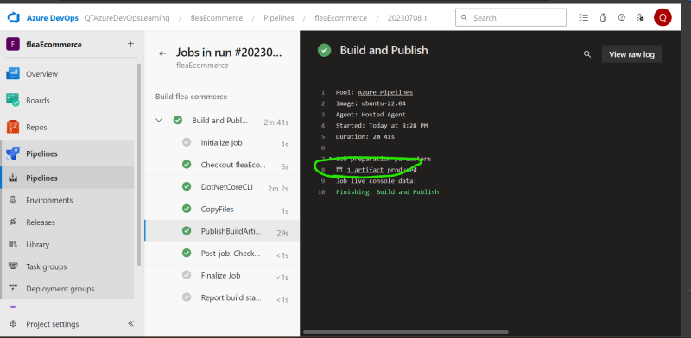

**Stage – 2: Deploying what we build – Variant I**

* Workflow
  + Try to create a linux vm (AWS/Azure) using terraform
    - Agent:
      * AWS: Softwares required
        + Terraform
        + aws cli and configure
      * Azure: Softwares required
        + Terraform
        + azure cli and configure

**Stages – Variant II (Container)**

* Stage – I
  + Build a fleaCommerce docker container image  
    docker image build -t <name>:<tag> .
  + push it to docker hub  
    docker image push <name>:<tag>
* Solution:

---

trigger:

- workshop-develop

stages:

- stage: buildstage

displayName: Build flea commerce

pool:

vmImage: ubuntu-22.04

jobs:

- job: buildJob

displayName: Build and Publish

steps:

- task: Docker@2

inputs:

command: 'buildAndPush'

Dockerfile: '**/Dockerfile'

containerRegistry: 'mydockerhub'

repository: 'shaikkhajaibrahim/fleacommerce'

tags: latest

* Stage – II
  + create a kubernetes cluster from terraform and configure kubectl (optional)
  + Execute kubernetes deployment kubectl apply -f <something.yaml>